Emergency Messaging and Landslides in Western North Carolina
Paige Ambord & Caitlin Meagher | UNC Asheville | NC Collaboratory | March 2026

Overview
Hurricane Helene made landfall as a Category 4 storm on September 26, 2024, and tracked inland to devastate Western North Carolina with over 20 inches of rain in 48 hours. In addition to catastrophic flooding, the storm triggered 2,000 landslides—over 1,000 of which directly struck roads, rivers, or structures—killing at least 31 people (see figure 1). Despite the region's well-documented history of landslide susceptibility, residents were largely unprepared for the compound hazards the storm produced.
This study, funded by the NC Collaboratory, sought to understand why. The research team conducted 25 semi-structured interviews with 30 landslide survivors across six WNC counties (Buncombe, Yancey, Polk, Henderson, Mitchell, and McDowell) from April through October 2025.

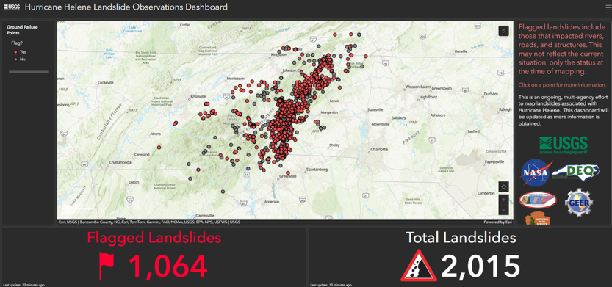

Figure 1. USGS Helene Landslide Observations Dashboard

Filter Model of Landslide Risk

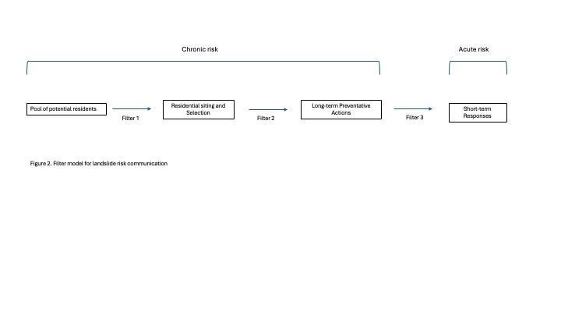

Opportunities to inform residents of landslide risk occur at numerous junctures before a storm. At Filter 1, potential residents draw on their prior knowledge of the universe of disaster risks and the information provided by the real estate apparatus and government agencies to make decisions about the location of their residence (whether renting, buying, or building). This is the point at which landslide inventories and landslide susceptibility maps may best be utilized. This filter point offers a critical juncture for providing information prior to the imminent risk posed by a single storm. At Filter 2, emergency preparedness education, including the importance of household emergency plans and supplies, can help residents recognize the chronic risk posed by landslides in the mountainous region of WNC. At Filter 3, residents receive information about the acute risk posed by specific storms. Residents here must be able to disambiguate landslide risk from other risks (e.g., flooding) in order to respond immediately (e.g., evacuate).

Key Findings:

Low baseline awareness (Filter 1)
While about 85% of respondents knew a storm was approaching, roughly 90% had no sense of its expected magnitude. Additionally, only 5 of 30 participants were previously aware that they lived in a landslide-prone area. Most learned about the storm through social media or word-of-mouth, not official channels—local meteorologists' Facebook posts were frequently cited as a primary source.

Inadequate disclosure at the point of sale (Filter 1)
Multiple participants received no information about prior flooding or landslide history when purchasing their homes. In one case, a home had previously been struck by a landslide, a fact undisclosed at sale. North Carolina's limited real estate disclosure requirements left many newcomers without critical context about the environmental hazards of their properties.

Misapplied experience and the "climate haven" narrative (Filter 2)
About half of the participants had prior severe weather experience, but this often led to underestimation rather than caution. Transplants from coastal areas applied hurricane frameworks suited to flat terrain, misjudging mountain-specific hazards. Separately, many participants echoed a widely circulated belief that WNC's mountains would shield residents from major storms, a narrative reinforced by media discourse that appears to have actively suppressed risk perception.

The flood–landslide disconnect (Filter 3)
The study's most consequential finding: residents who received flash flood warnings did not connect them to personal landslide risk. Many on hillsides reasoned that flood alerts simply "didn't apply" to them. Landslide risk was technically included in official notices but was not prominent enough to register as a distinct, actionable threat. This represents a critical gap in how compound hazards are communicated.

Recommendations
- Inform prospective buyers about landslide and flood risk; encourage geological inspection for properties near slopes and waterways. (Filter 1)
- Develop public education that directly addresses how mountain hazards differ from the coastal environments many residents know. (Filter 2)
- Name landslide risk explicitly and separately in emergency alerts rather than treating it as a secondary effect of flooding. (Filter 3)
- Issue neighborhood- or street-level warnings; county-wide alerts are too broad for WNC's varied terrain. (Filter 3)
- Build redundant communication pathways, including door-to-door capability, designed to function when cell infrastructure fails. (Filter 3)

